**Course name- Product Design Thinking and Framework**

**Collage – Quantum University**

**Batch Number- 01**

**Project Statement 4 , part (b)**

Construct and simulate a NAND gate using MOS transistors, infer its behaviour, and explain its truth table with logical operation.

**Circuit:**

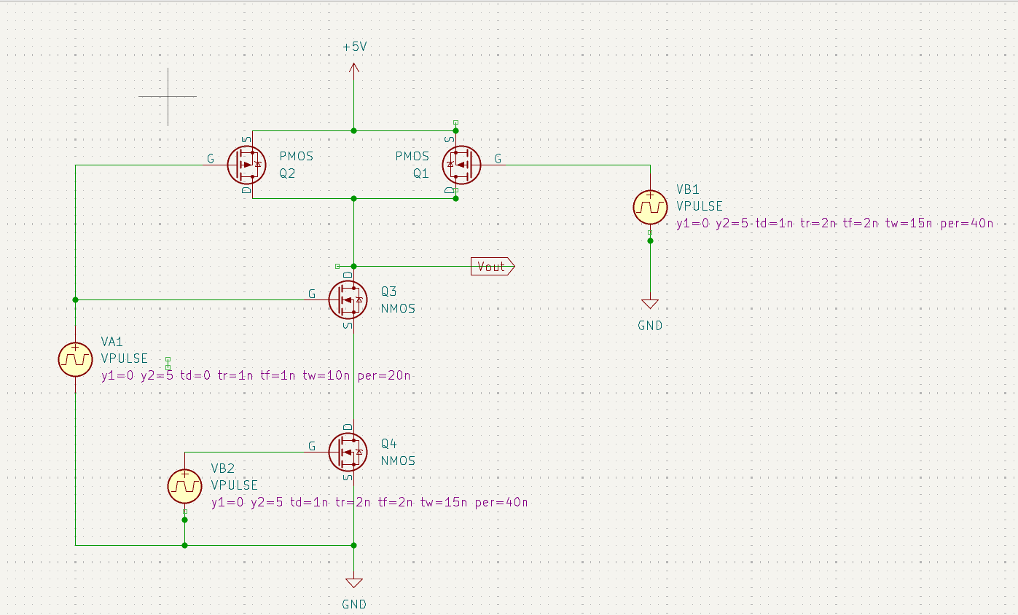

**Values:**

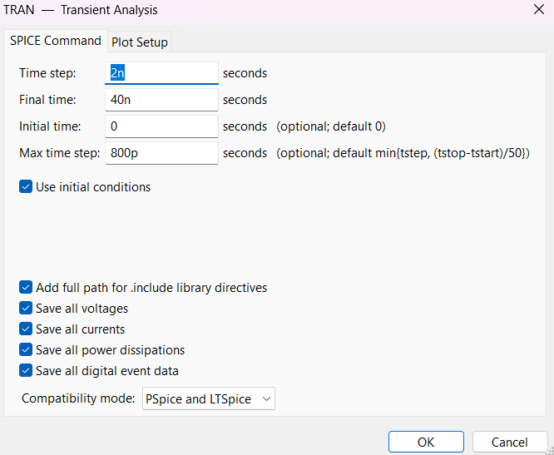

**Simulation:**

